Amit Karn

Organocity

TRADE ORACLE INTERFACE TESTING

Organocity

# Table of Contents:

1. Registration
2. Login
3. Shop
4. Product
5. Reviews
6. Charts and Graphs
7. Trader Signs out

# Admin Interface Testing

1. Registration
   1. With empty fields

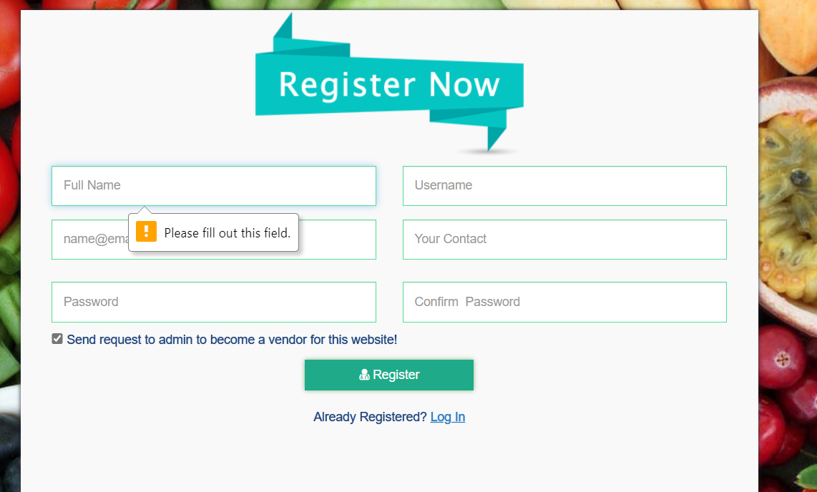

“Error Message”

* 1. With partially empty fields

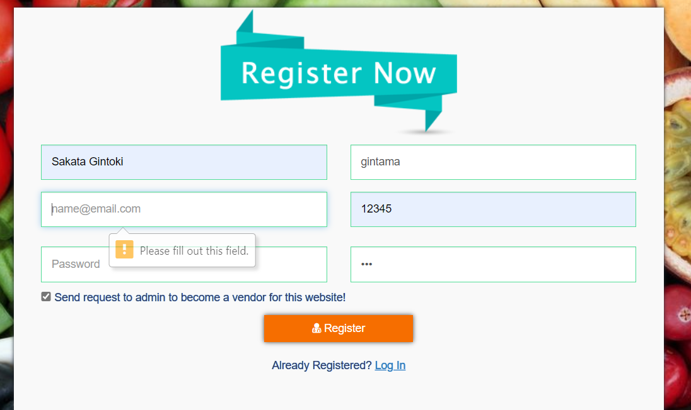

“Error Message”

* 1. With invalid details

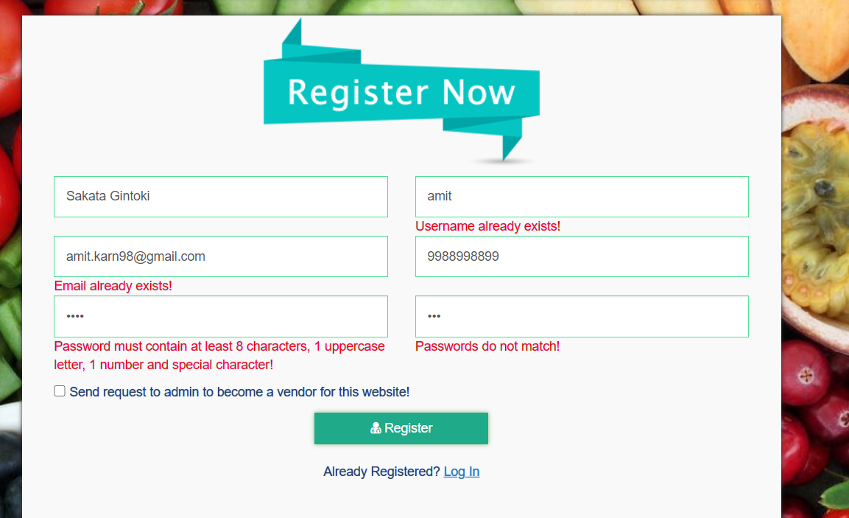

“Error message”

* 1. With appropriate Values

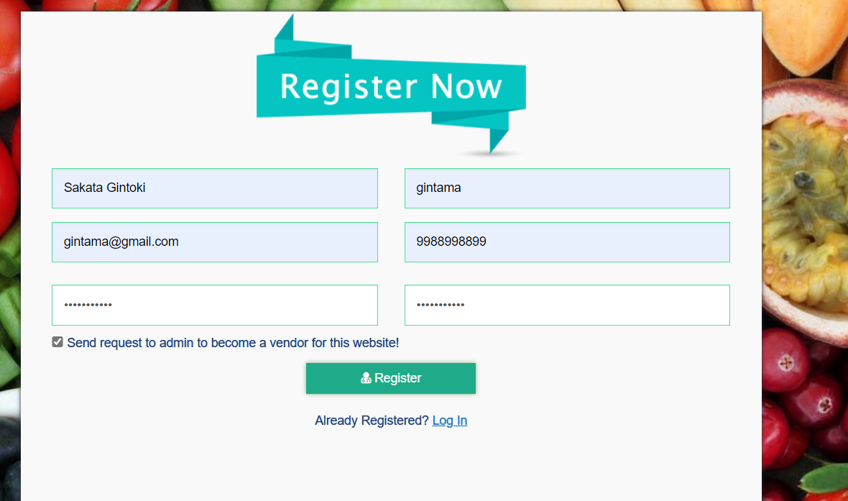

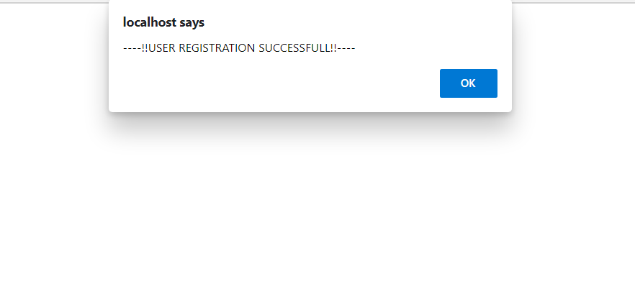

“Registration successful”

1. Sign In
   1. With Empty Fields

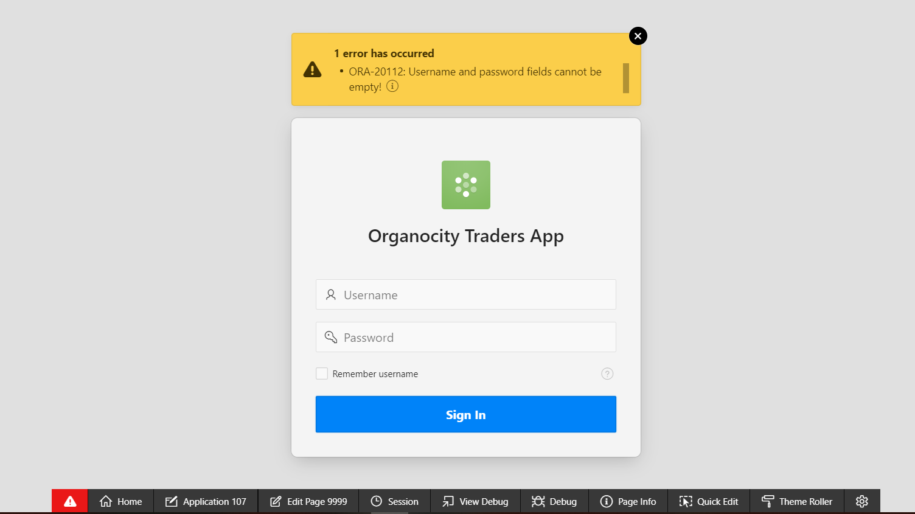

“Error Message Displayed”

* 1. With Invalid Input Credentials

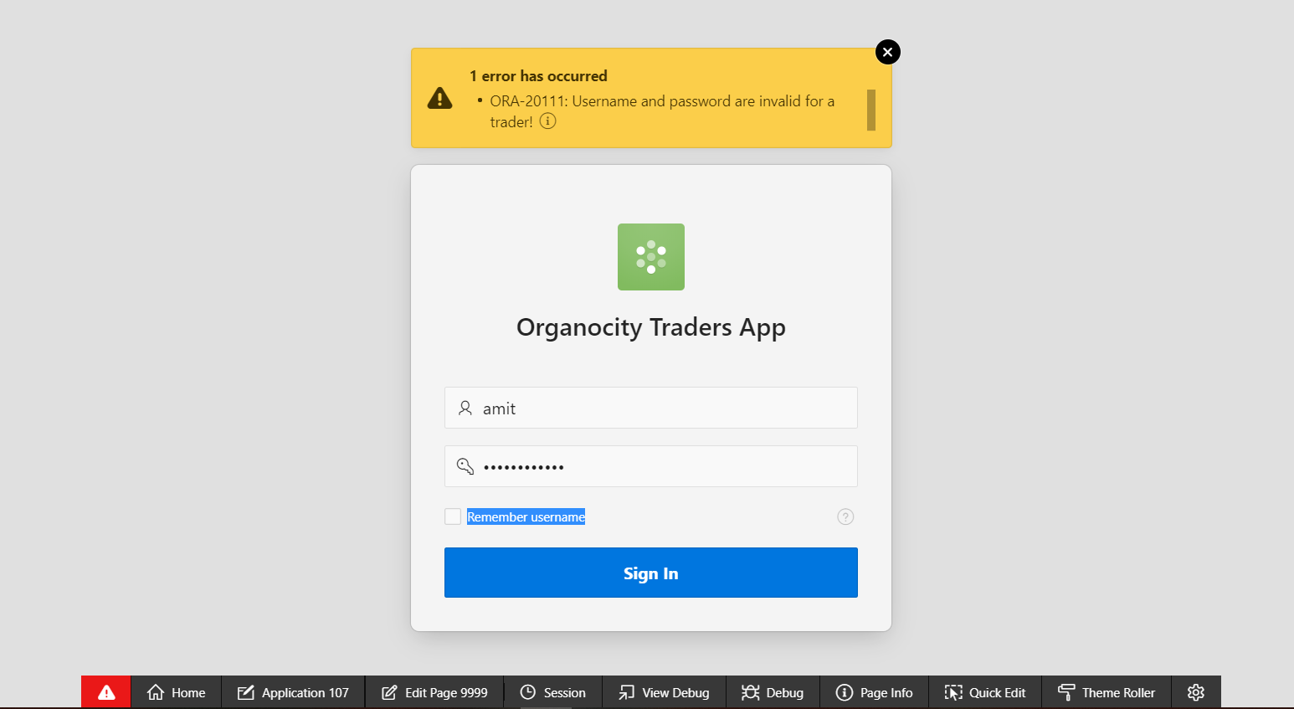

“Error Message Displayed”

* 1. With appropriate credentials

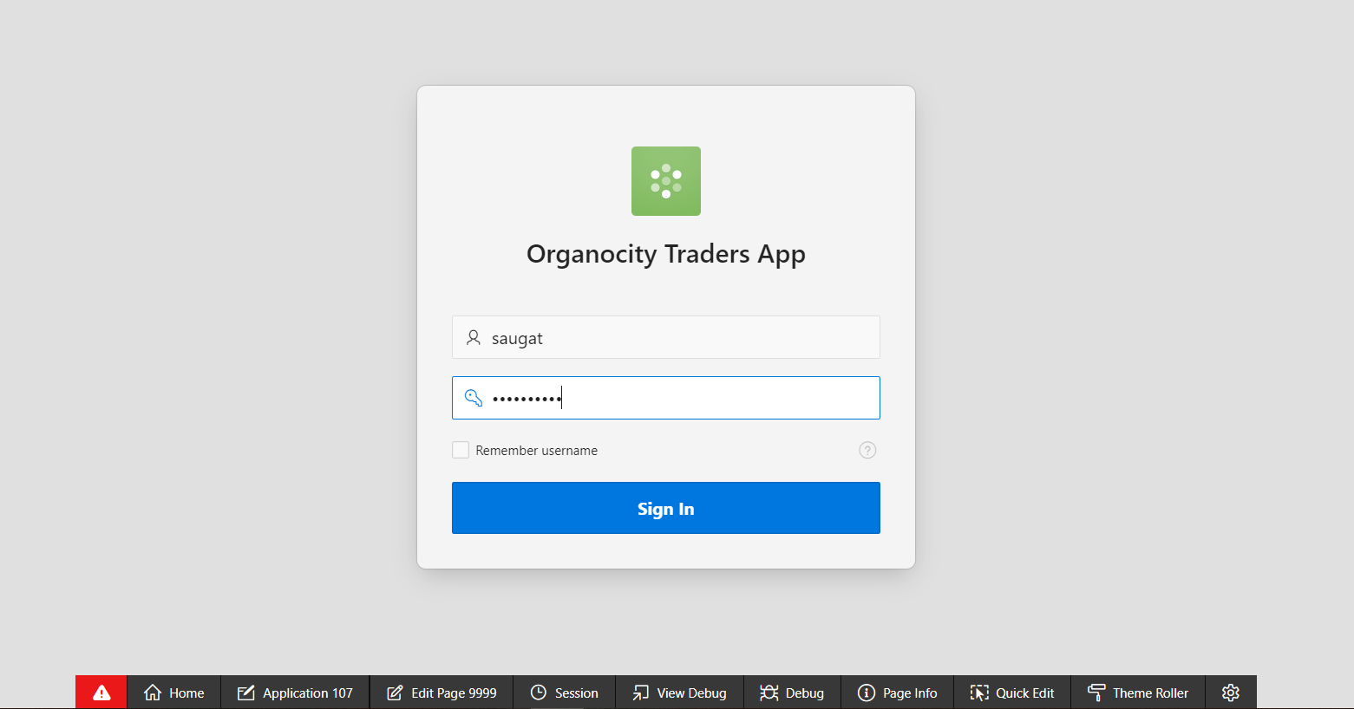

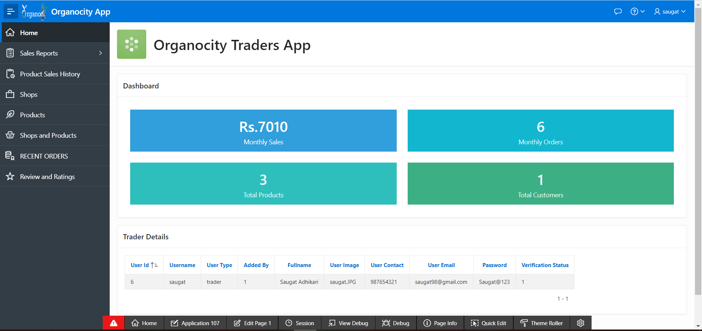

“Login Succeeds and redirected to dashboard”

1. View Shops of the trader.

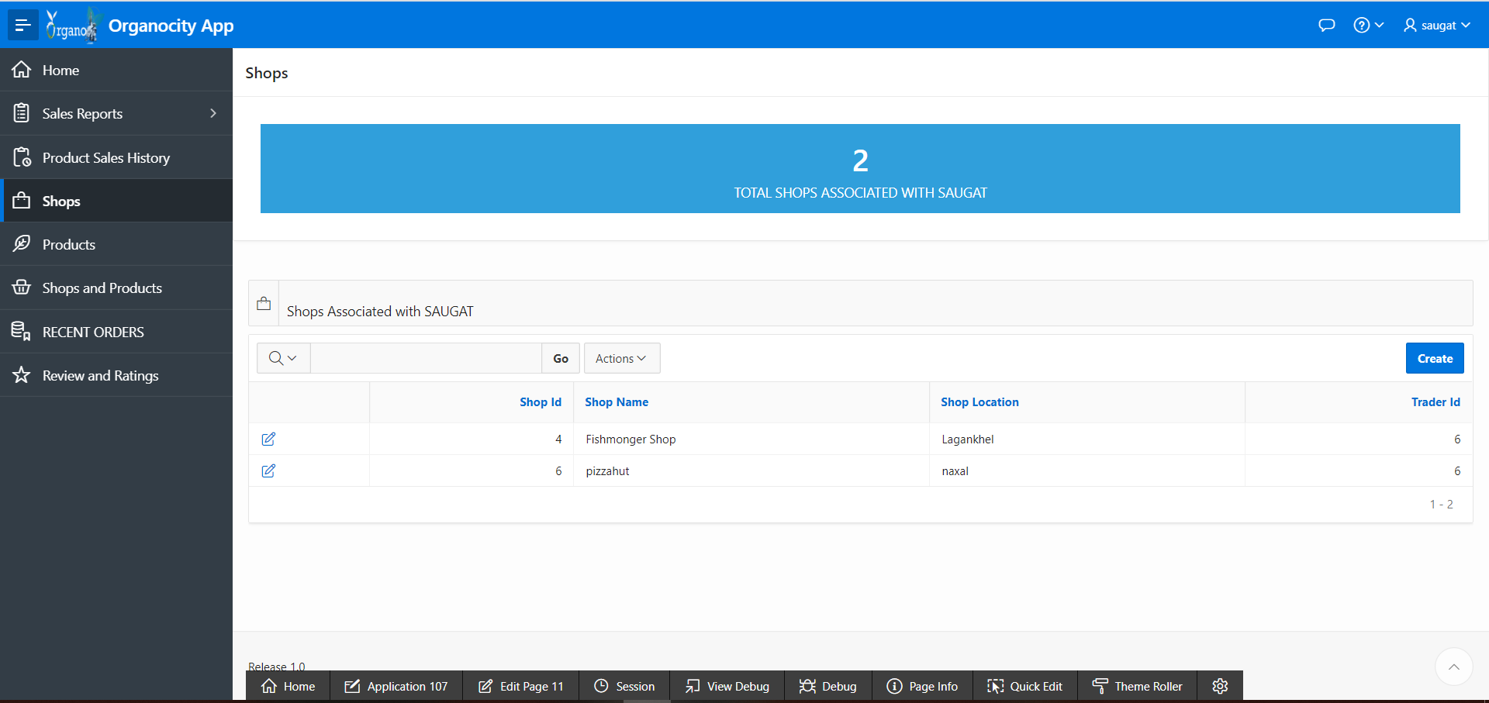

“Shops of the trader opens”

1. Product
   1. Add product to shop

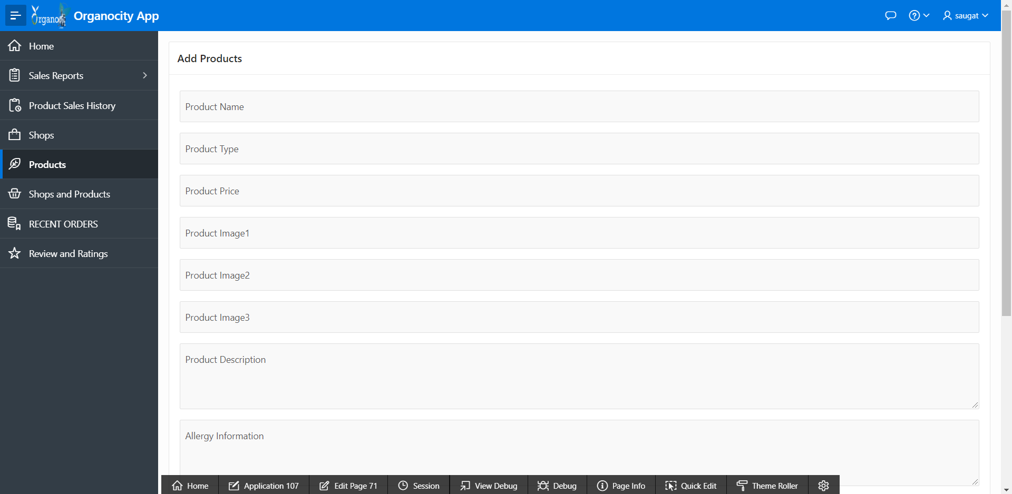

“Product gets added”

* 1. Remove product from shop

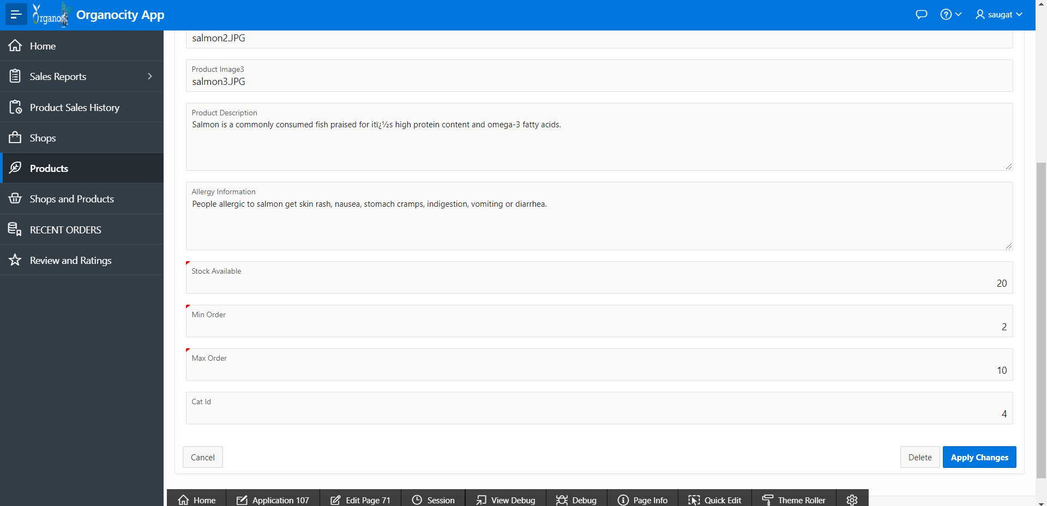

“Products gets removed”

* 1. Stock of the products can be altered



“Stock of the products updated”

* 1. Update product details



“Product details gets updated”

1. Reviews
   1. View reviews of products that the trader sells by customers

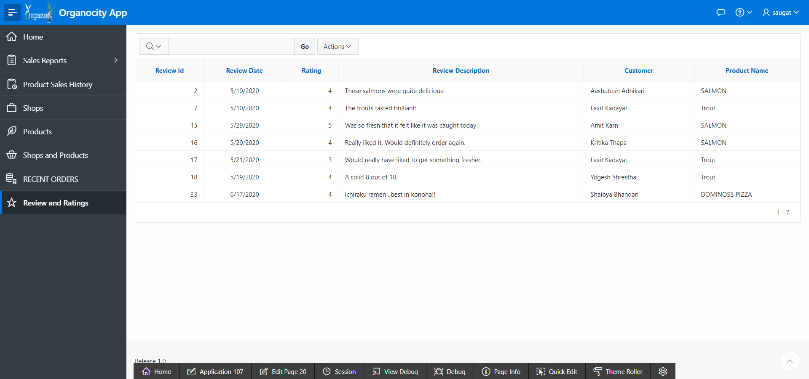

“Displays reviews done by the customers to the trader’s products”

1. Charts and Graph
   1. View daily sales report

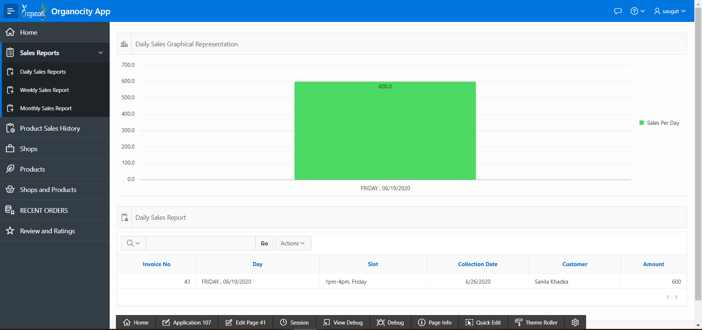

“Daily sales report get displayed”

* 1. View weekly sales report

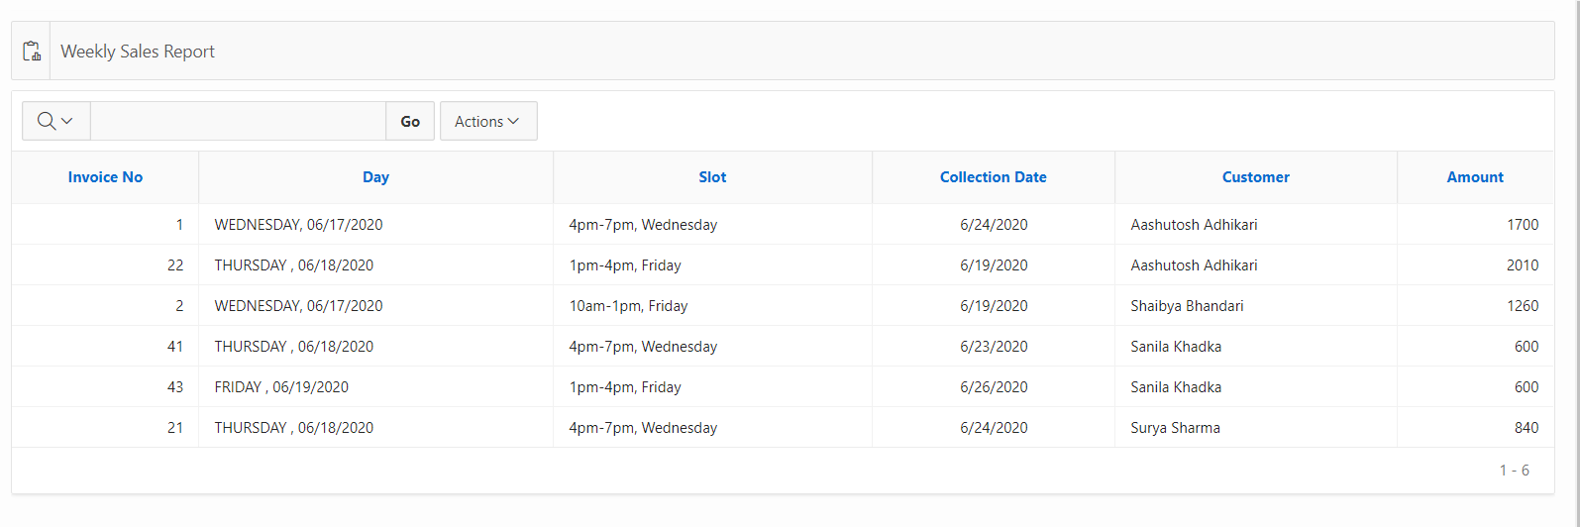

“Weekly sales report gets displayed”

* 1. View monthly sales report

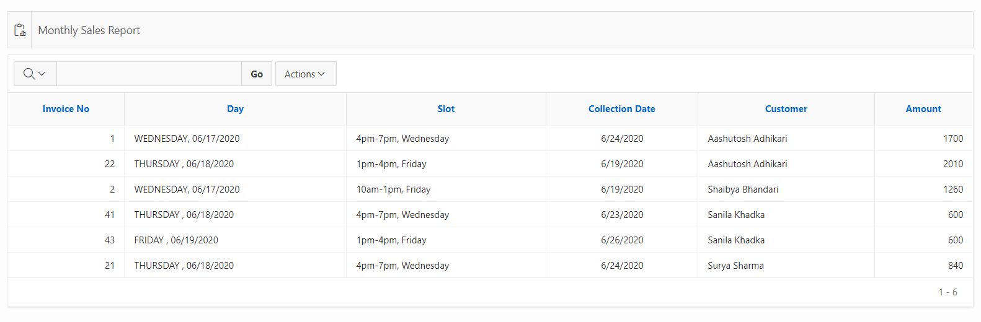

“Monthly sales report gets displayed”

* 1. View stock report

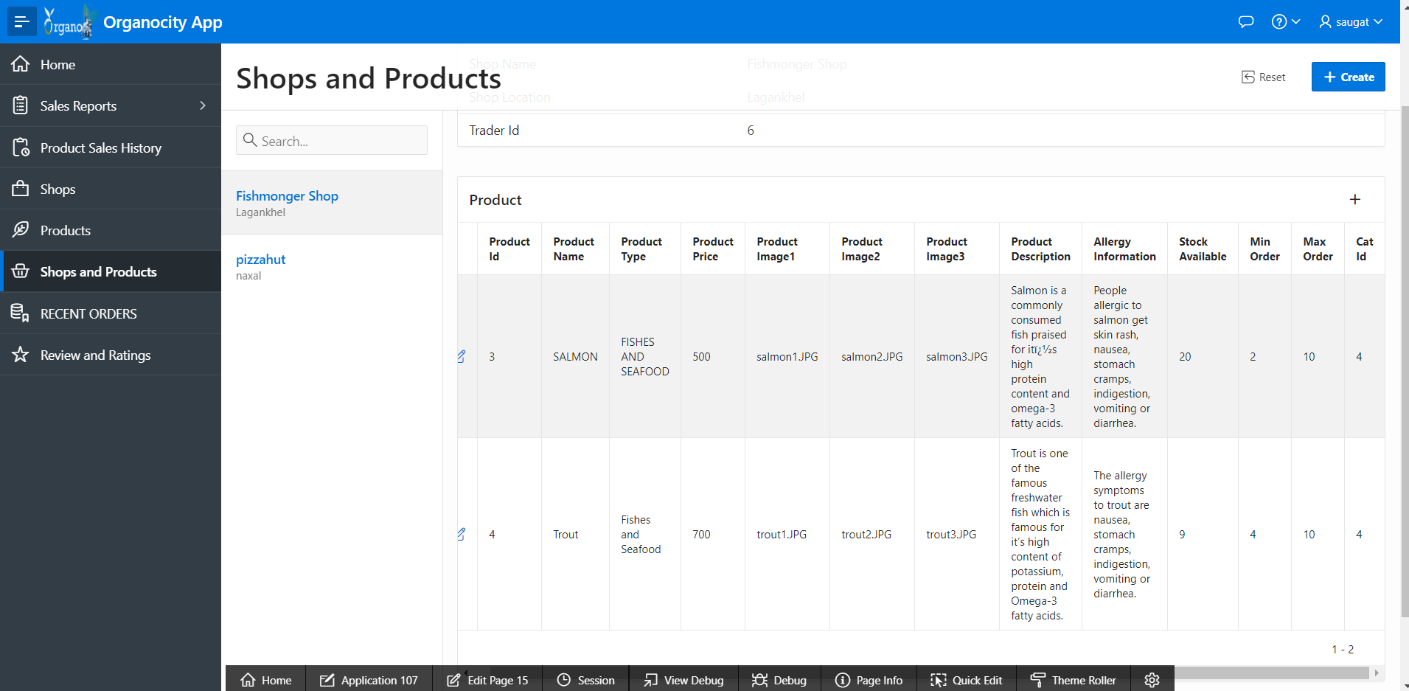

“Stock details report is displayed”

* 1. View sales graph

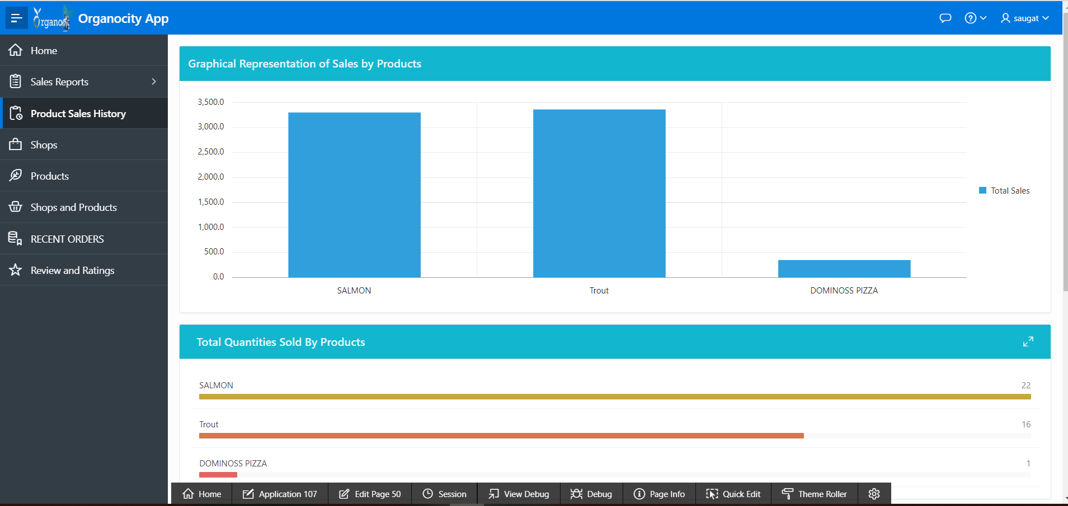

“Sales graph is shown”

1. Sign out

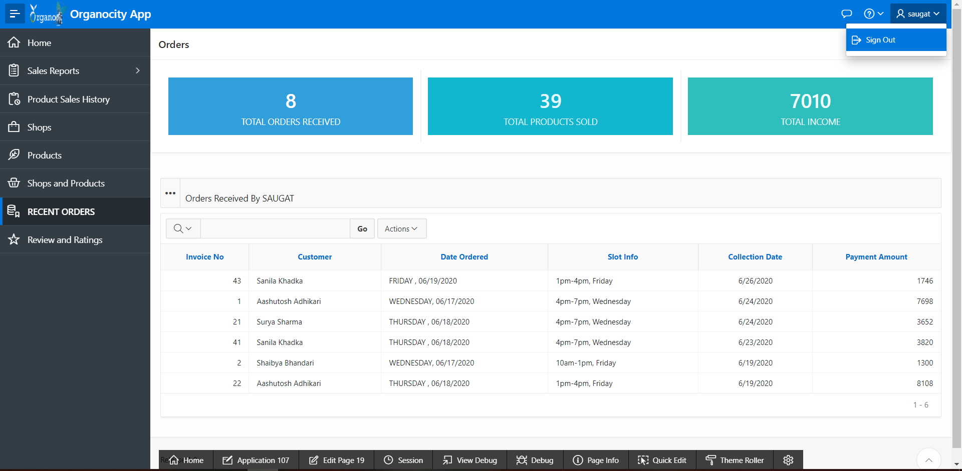

“Trader is signed out”